Sinio, Kian Robe P.
BSIT 4-A
ShopSmart AI Assistant: Test Screenshots
Test 1: Catalog match
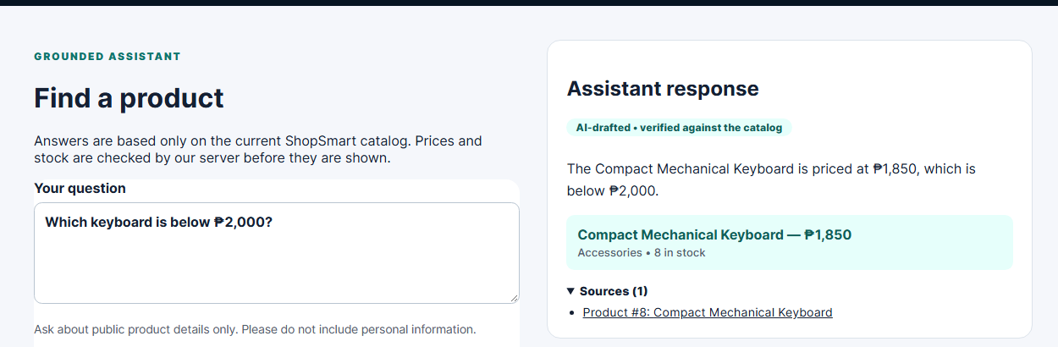
Test 2: No match
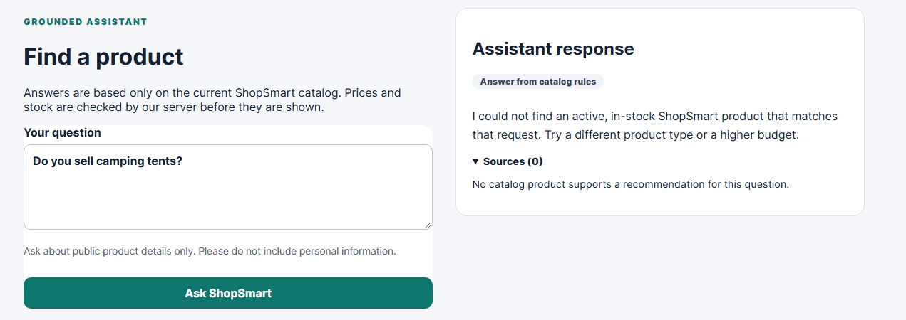
Test 3: Invalid input
Test 4: Availability
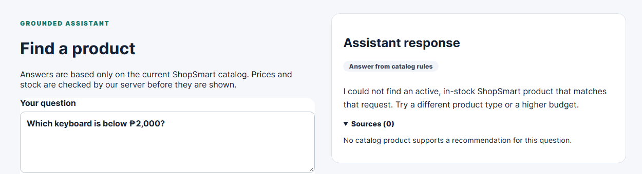
Test 5: Provider failure
Gemini returned error 503 (overloaded). The page did not keep loading. It showed the correct keyboard and price from the store's own rules, with a note saying the AI service was unavailable.
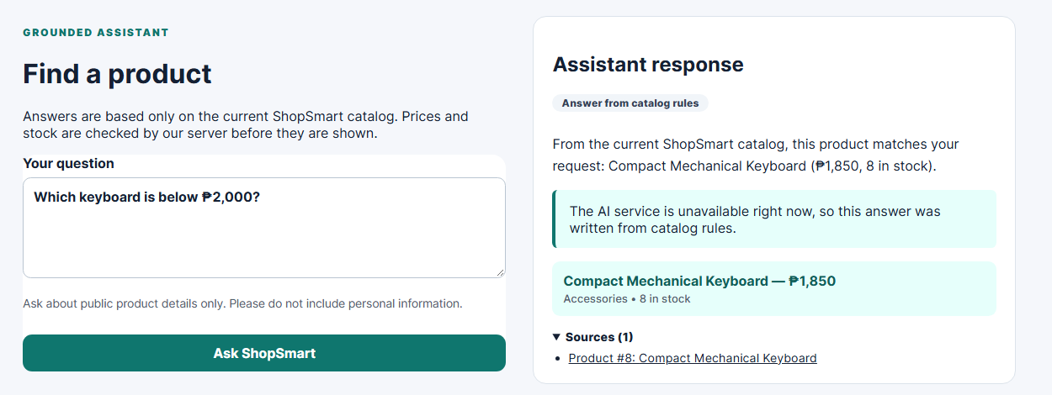
Test 6: Source check
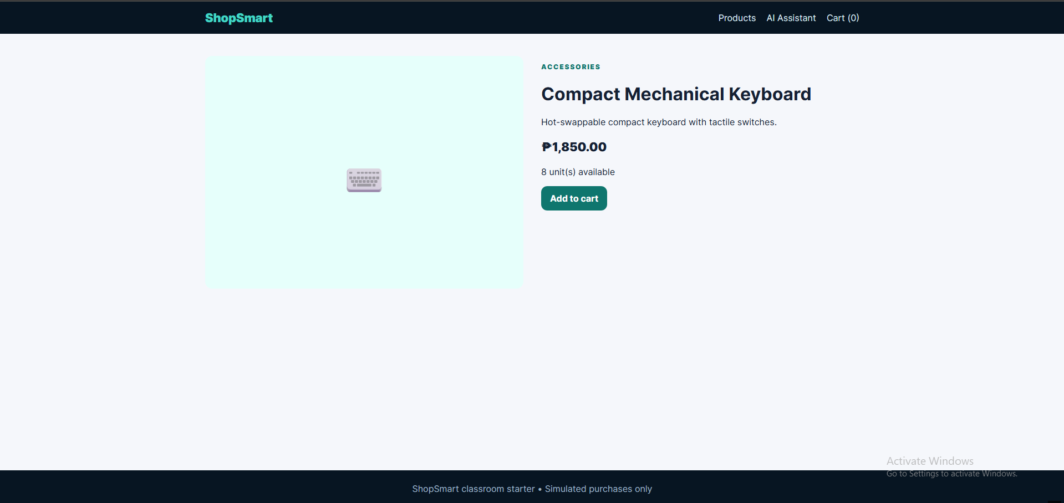
npm run check


